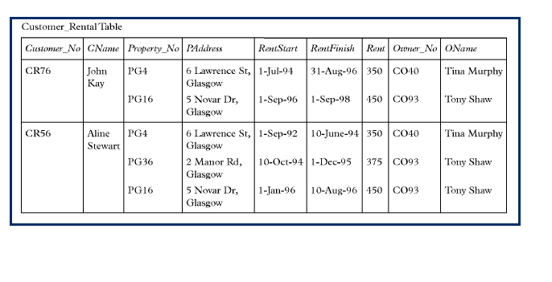

0 NF:

(customer_no, customer_name, p_no, p_address, rent_start, rent_finish, rent, owner_no, o_name)

1 NF:

(customer_no, p_no, p_address, rent_start, rent_finish, rent, owner_no, o_name)

(customer_no, customer_name)

2 NF:

(customer_no, p_no, rent_start, rent_finish, rent)

(customer_no, customer_name)

(p_no, p_address, owner_no, o_name)

3 NF:

(customer_no, p_no, rent, rent_start, rent_finish)

(customer_no, customer_name)

(p_no, p_address, owner_no(FK))

(owner_no, o_name)

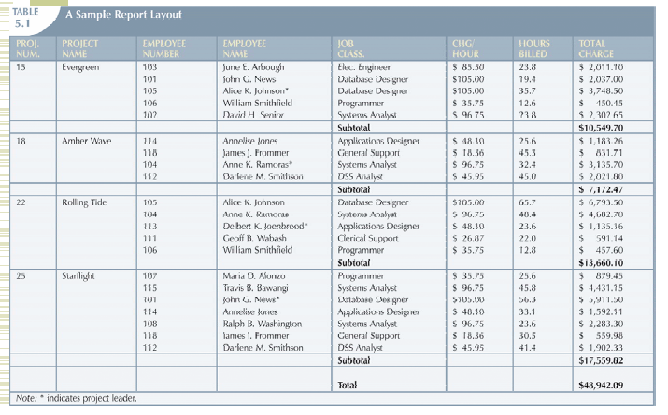

0 NF:

(proj_no, proj_name, emp_no, emp_name, job_class, hourly_rate, hours)

1 NF:

(proj_no, emp_no, job_class, hourly_rate, hours)

(proj_no, proj_name)

2 NF:

(proj_no, emp_no, hours)

(proj_no, proj_name)

(emp_no, emp_name, job_class, hourly_rate)

3 NF:

(proj_no, emp_no, hours)

(proj_no, proj_name)

(emp_no, emp_name, job_class(FK))

(job_class, hourly_rate)